

Team Members:
Sarim Yawar (19P-0001)
Moeed Rehman (19P-0089)
Haseeb Jan (19P-0003)
Hassan Bilal (19P-0083)
Usman Manzoor (19P-0068)
Wahaj Tahir (19P-1673)

Project Name:
Face Recognition Attendance

Subject:
Technical Business Writing

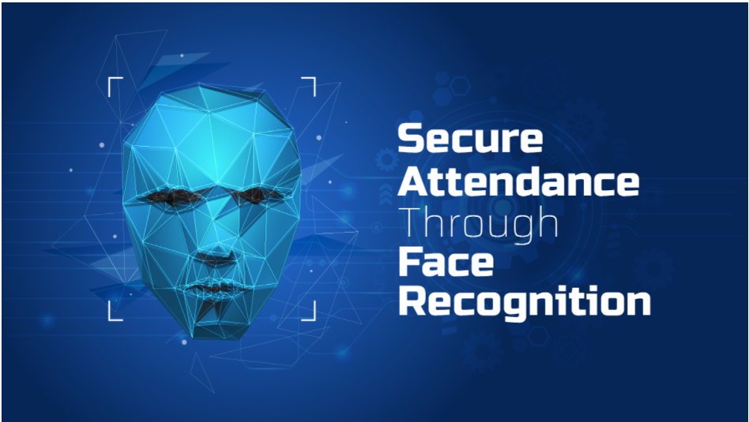
Introduction:
The face is one of the easiest ways to distinguish the individual identity of each other. Face recognition is a personal identification system that uses personal characteristics of a person to identify the person's identity. Human face recognition procedure basically consists of two phases, namely face detection, where this process takes place very rapidly in humans, except under conditions where the object is located at a short distance away, the next is the introduction, which recognize a face as individuals. Stage is then replicated and developed as a model for facial image recognition (face recognition) is one of the much-studied biometrics technology and developed by experts. Face recognition is the task of identifying an already detected object as a known or unknown face . Often the problem of face recognition is confused with the problem of face detection .Face Recognition on the other hand is to decide if the "face" is someone known, or unknown, using for this purpose a database of faces in order to validate this input face.

Background And History:
The work on face recognition began in 1960. Woody Bledsoe, Helen Chan Wolf and Charles Bison had introduced a system which required the administrator to locate eyes, ears, nose and mouth from images. The distance and ratios between the located features and the common reference points are then calculated and compared. The studies are further enhanced by Goldstein, Harmon, and Lesk in 1970 by using other features such as hair color and lip thickness to automate the recognition. In 1988, Kirby and Sirovich first suggested principle component analysis (PCA) to solve face recognition problem. Many studies on face recognition were then conducted continuously until today.
The earliest pioneers of facial recognition were Woody Bledsoe, Helen Chan Wolf and Charles Bisson. In 1964 and 1965, Bledsoe, along with Wolf and Bisson began work using computers to recognise the human face.
Due to the funding of the project originating from an unnamed intelligence agency, much of their work was never published. However it was later revealed that their initial work involved the manual marking of various “landmarks” on the face such as eye centres, mouth etc. These were then mathematically rotated by a computer to compensate for pose variation. The distances between landmarks were also automatically computed and compared between images to determine identity[1].
These earliest steps into Facial Recognition by Bledsoe, Wolf and Bisson were severely hampered by the technology of the era, but it remains an important first step in proving that Facial Recognition was a viable biometric.
Light is a form of electromagnetic waves which are radiated from a source onto an object and projected to human vision. Robinson-Riegler, G., & Robinson-Riegler, B. mentioned that after visual processing done by the human visual system, we actually classify shape, size, contour and the texture of the object in order to analyse the information. The analysed information will be compared to other representations of objects or face that exist in our memory to recognize. In fact, it is a hard challenge to build an automated system to have the same capability as a human to recognize faces. However, we need large memory to recognize different faces, for example, in the Universities, there are a lot of students with different race and gender, it is impossible to remember every face of the individual without making mistakes. In order to overcome human limitations, computers with almost limitless memory, high processing speed and power are used in face recognition systems.
The human face is a unique representation of individual identity. Thus, face recognition is defined as a biometric method in which identification of an individual is performed by comparing real-time capture image with stored images in the database of that person .

Nowadays, face recognition system is prevalent due to its simplicity and awesome performance. For instance, airport protection systems and FBI use face recognition for criminal investigations by tracking suspects, missing children and drug activities. Apart from that, Facebook which is a popular social networking website implement face recognition to allow the users to tag their friends in the photo for entertainment purposes . Furthermore, Intel Company allows the users to use face recognition to get access to their online account Apple allows the users to unlock their mobile phone(iPhone X onward) by using face recognition.

What is Future of Face Recognition Technology?
As we move into 2021, facial recognition technology continues to develop at pace and the uses of the technology are becoming more widespread. In a recent post, we looked at the eight trends to look out for with Facial Recognition in 2020. These included:
- Universities
- Hospitality and Resorts
- ATMs
- Digital Advertising
- Bus Safety
- Airlines
- Personalised Customer Experience
- Staffless Stores

What are Aims And Objectives of Face Recognition Technology ?
The objective of this project is to develop face recognition based automated student attendance system. Expected achievements in order to fulfill the objectives are:
- To detect the face segment from the video frame.
- To extract the useful features from the face detected.
- To classify the features in order to recognize the face detected.
- To record the attendance of the identified student.

Working of Face Recognition system:

It has been around for decades. However, in recent years it has seen more widespread adaptation.
ARTIFICAL INTELLIGENCE leads this system software. This has led to higher accuracy and faster processing times Government and private companies are taking notice it is expected to reach $12.92 Billion by 2027 and it is not just for safety and security .this software is starting to appear in retail transportation and the banking industry but What is facial recognition system Technology it is a biometric tool as with other commonly used biometric technologies like fingerprint recognition ,iris recognition and finger vein pattern recognition facial recognition identifies a person based on specific aspects of their physiology though the software can vary the process of facial recognition tends to follow three basic steps First, your face is captured with photo or video or in a crowd in this real time, the software then measures a variety of facial features called land marks or nodal points on the face these could include the distance between the eyes the width of nose, depth of eye sockets distance from forehead to chin each program uses different nodal points and may collects up to different measurements this information is then collected into a mathematical formula whi8ch detect your unique facial signatures that facial signature is then compared to a data base of known faces this can all happen in a matter of seconds can be traced back to the 1960s .one early system developed by Woodrow Wilson Bledsoe classified photos by manually recording the coordinates of facial features using an electronic stylus when the system was given a photograph of an individual it could retrieve the images that most closely resembled it from a database in the 1990’s the U.S defense advanced research projects agency and the national institute of standard and technology designed a face recognition system which eventually led to more sophisticates . one early version of this technology was tested at 2002 super bowl when law enforcements official scanned the crowd and found several minor criminals Although that experiment also yielded a higher number of false positives however , the technology blossomed in the 2010’s because of the rapid developments in artificial intelligence by police to identify suspects in the yield However since its inception facial recognition has been polarizing a significant use of facial recognition technology is in the area of safety and security and law enforcement agencies use it to fight petty crime help locate missing people and even uncover local criminals security check points at airport worldwide are increasingly using such technology to protect flyers and to identify criminals trying to enter the country the department of homeland security also uses facial recognition to find people who have overstayed visas or who are under criminal investigation today several companies are developing watchlist as a service using face recognition data platforms to help prevent shoplifting and violent crime facial recognition technology is getting faster and more accurate every year this means that this could also soon be used to make our lives more convenient using your faceprint and financial institutions will be able to seamlessly verify who you are without the use of physical ID this is even a bar that uses facial recognition to create better service for customers there are vocal arguments against facial recognition technology with the biggest being its threat to an individuals privacy some cities across the world are already working toward banning real time face recognition your facial data can be collected and stored without your permission. there are also concerns regarding safety apps that allow individual to use facial recognition software , Finally the technology is still far from perfect many facial recognition algorithms produce far more false positives on non-white faces it is not difficult to fool facial recognition systems researchers have already developed anti-facial recognition glasses which make wearers undetectable .this technology is increasingly used in mobile devices and consumer products as a way to authenticate users .retailers are using it to stop theft and to identify customers in need of assistance and some automotive manufacturers are developing ways to use the technology in place of car keys facial recognition could also be used to target products to specify groups by gender or age to offer a personalized experience to restaurant customers or to boost patient care at hospitals and clinics.

Primary Source:
I started research on this system software from last one year and I learned and gather much data from internet, books. The process of face recognition is divided into two stages, training and recognition stages, shown in Figure

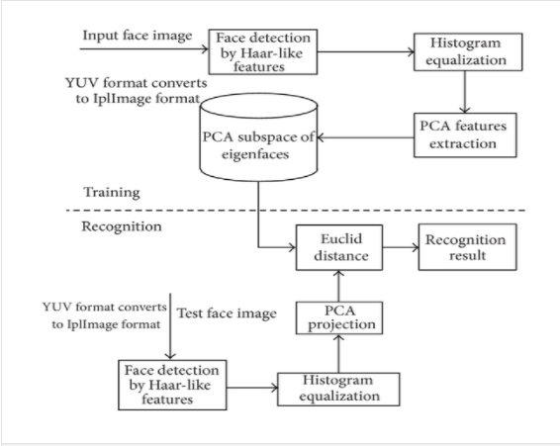
Face Training:
To ensure convenient face image processing, the Haar-like face detection algorithm (Viola-Jones method) is used to identify face region. In order to enhance the contrast of image, reduce the influence from external factors and improve the following recognition rate; the face image identified is processed with the histogram equalization.
Face Recognition:
Similarly, the test of face image is processed through format transformation, Haar-like face detection, and histogram equalization.
Major Algorithms:

Haar-Like Features:
This feature corresponds to black rectangle and the white rectangle. Each feature is composed of 23 rectangles, and they are applied in the detection of edge-feature, linear-feature, and center-feature. Value of each feature is made up by the sum of pixel values in corresponding rectangle region.

Integral Image:
Integral image is a method of fast calculation of rectSUM(ri) with the idea of replacing time with space. The sum of pixel values in rectangle region formed from starting point of image to the rest is saved as an array. We can directly use the array to do calculation when we need to calculate rectSUM(ri) of certain region. This method avoids recalculation of pixels of this region; so, calculation speed improves.

Adobos Algorithm:
ad boost algorithm is a kind of classifier algorithms. Its basic idea is constructing an accurate classifier with strong ability of classification by means of combining a large number of simple classifiers according to some rules.
FEATURES:
●Face detection tracking
Quickly and accurately detect the face and track location of each face in still image or video streaming

●Accurate Localization of Facial Feature Points
Accurately locate the key feature points on the face in the picture (5 key points such as eyes, nose, mouth, etc.), used to determine the face posture and face alignment

●Face image quality assessment:
A quality threshold can be used during face enrollment to ensure that only the qualified face template will be stored into database to decrease the effect of image quality on matching performance.

●Live face detection:
A conventional face identification system can be tricked by placing a photo in front of the camera.
We are able to prevent frauds with using photograph or 3D printed mask with SDK as follows,
1) Active mode with face images captured in visible light: SDK requires user actively assist to perform particular actions such as open mouth, head movements to judge it's a 'live' human or not.
2) Near-infrared version: using imaging features of Near-infrared to achieve high robustness of live face detection.

●Face identification capability:
It can be used for fast matching in 1:1 mode (verification), as well as1: N (n= large database size) mode (identification). Verify if it's same person by calculates two faces’ similarity based on features extraction. If the matching score is higher than the pre-defined facial matching threshold then the input template is said to have successfully matched with the stored template.

Secondary Source:
As a secondary source for face recognition system, I note down previous researches, theories, laws and principles. As there has been a rapid development of the reliable face recognition algorithms in the last decade. The traditional face recognition algorithms can be categorized into two categories
- holistic features
- local feature approaches.
However, from the last decades many new researchers work on it due to large variations in illumination conditions, facial expression and other factors, these methods may fail to adequately represent the faces. The main reason is that the face patterns lie on a complex nonlinear and non‐convex manifold in the high‐dimensional space.
In order to deal with such cases, nonlinear extensions have been proposed like kernel PCA and kernel LDA.

Artificial Neural Networks in face recognition:
In artificial neural networks are used to solve nonlinear problem. To recognize human faces, a non‐convergent chaotic neural network.
It is integrated with a non‐negative matrix factorization to recognize faces. Moreover, for face and speech verifications they utilize a momentum back propagation neural network. distance metrics and normalized cross‐correlation for face recognition is applied.
- Gabor wavelet‐based solutions:
These Solutions helps me in bringing widely used face recognition representations and its features are recognized better in term of recognition rate. Moreover, it is demonstrated to be discriminative and robust to illumination and expression variations.
- Face descriptor‐based methods:
Local feature‐based face image description provides a global description. So local features of the image are evaluated in the neighboring pixels and then aggregated to form the final global description. This is unlike global methods in which the entire image is utilized to produce each feature, where the first steps start with the description of the face realized at a pixel level by making use of the local neighborhood of each pixel. Then, the image is divided into a number of subregions, and from each subregion, a local description is formed as a histogram of the pixel level descriptions calculated in the previous step. Next, the information of the regions is combined into the final descriptor by concatenating the partial histograms.

Budget Analysis:
Our time has worked on the budget. We have concluded that face detection software is not something too crazy to make in today’s tech world , in order to keep it a low budgeted project it can be made possible by involving the last year students into this and giving them this task as their Final year project , the only place where money needs to be spent is when we have to publish this application on either app store or play store which costs 99$ annually / this isn't really a huge investment since this app is going to be available to public for their own uses which can help us generate revenue.

There are numerous advantages of using Face recognition for system:
Automated time tracking system:
It won’t even need the person to stop and click a photo, the software’s are advanced enough to record the data from a continuous reel also. This means the flow won’t get hampered, or you won’t have to stop and smile or something like that. Just enter or exit the place effortlessly like you do everyday and boom! Students attendance will be recorded without any fuss!.
Cost-effective:
Since the whole process will be done by a computer, it means the total attendance registration and calculation will be automated and done by the system itself, therefore, saving us the money which would have been otherwise spent on the labor cost to do that.
Increased security:
Face recognition based attendance system won’t just calculate attendance but also note down the entry and exits of visitors in the place. At times when there is a situation where the identity and time of entry and exit of a specific person need to be noted, this system would become handy as it will easily show you when he/she came in and what are the places he/she went to a very precise level. All of this means, you will have a much higher security level in your workplace.
Time saving:
The whole world is suffering from COVID19 and it is high time we must give heed to social distancing. Having a safe distance with others has become a necessity nowadays. Times like this can be problematic if you have manual attendance system, Having a Face recognition based attendance system will not only allow you to register the attendance of a person but also keep you at a safe distance from them as you can work remotely and still see who all are coming and going. This calls for the point that, this whole system is a much safer, time-saving, and faster method to record attendance.
Motivation For Students:
The students will be more motivated about taking admission in the university as they will be impressed by the fact that the university is not only teaching us about the world of computer and software but is also implementing it for their students benefits. This will make new students to take an interest in taking admission in this university. They will be impressed that the University that is considered as best in Computer Science (CS) are actually doing something related to it.
___________________________________________________________________________________

THE END

